Task1. Understanding NoSQL Databases (8 Marks)
a) Define NoSQL databases and describe their key features.
Ans: NoSQL database is a flexible system that can store, manage and query large volume of structured or unstructured data. It uses data models like documents, graphs, and key-value pairs to manage large-scale, unstructured data.
Key features: Schema-less or no fixed data structure, therefore its flexible. Query data often does not require complex "JOIN" operations, hence read and write data are fast by nesting related data together. Can be used for a variety of data models like document for storing json-like objects.
b) Compare NoSQL and SQL databases by creating a table with at least 4 parameters (e.g., Schema, Scalability, Data Storage, Use cases)
Ans:
[Schema]
SQL - Fixed: must define columns and data types before adding any data.
NoSQL - Flexible: no fixed schema. Every record can have different fields and no pre-definition required.
[Scalability]
SQL - Vertical scale by adding more RAM/CPU.
NoSQL - Horizontal scale by adding servers to a "cluster" to share the load.
[Data Storage]
SQL - Tables: Data is split into rows and columns across many linked tables.
NoSQL - Documents/Pairs: Related data is usually "nested" together in one file.
[Use Case]
SQL - Best for structured data, complex queries and accounting (e.g., Banking).
NoSQL - Best for Unstructured data, rapidly changing data (e.g., Social Media, IoT).

c) Mention two real-world use cases where NoSQL databases are more suitable than SQL databases.
Amazon e-commerce shopping
Instagram or Twitter feeds
Task2:
2a)
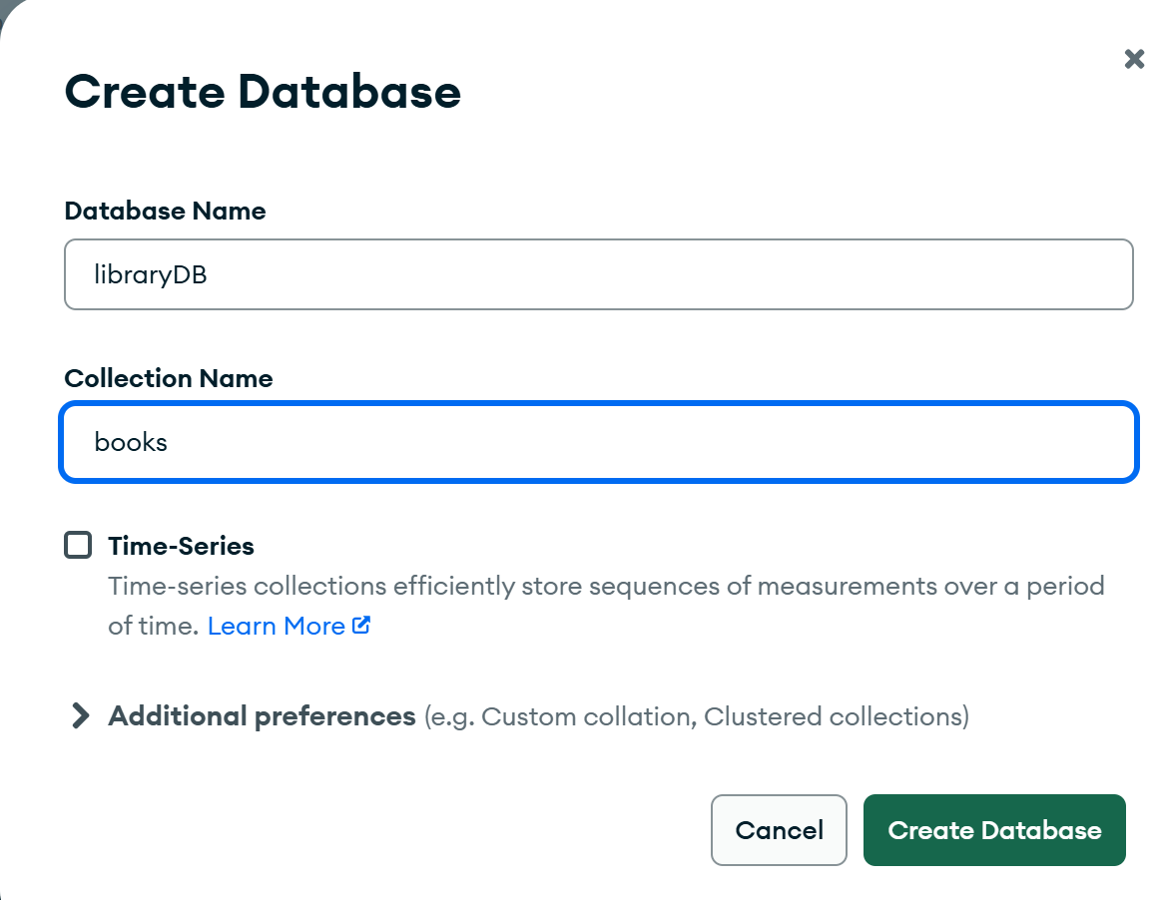
2b)
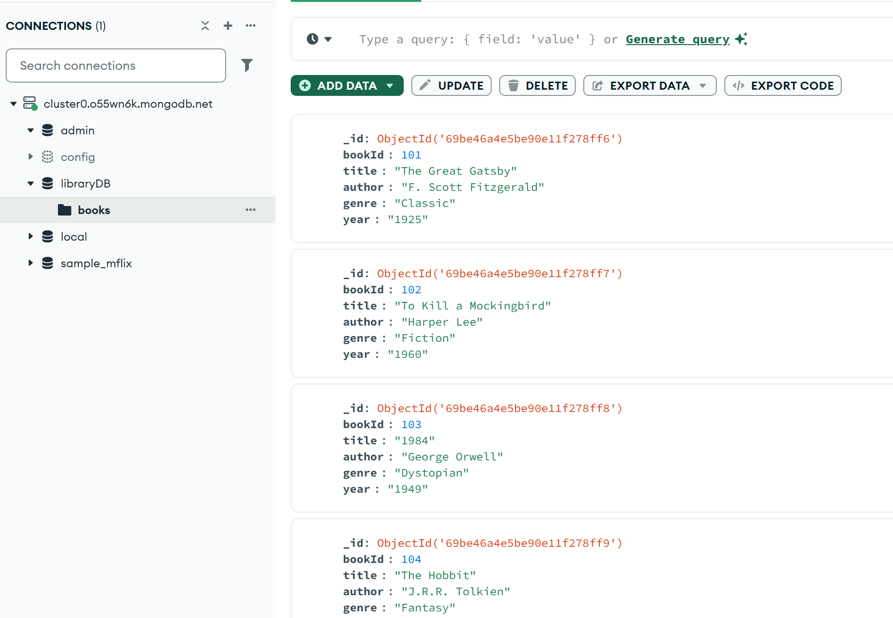

2c)
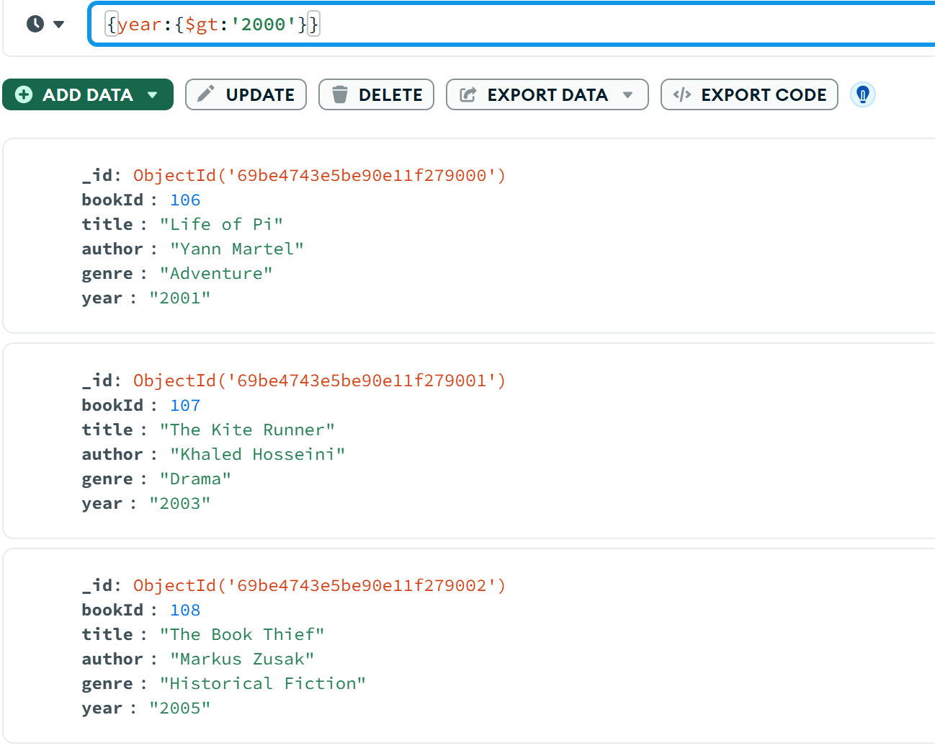
Task3:
3a)
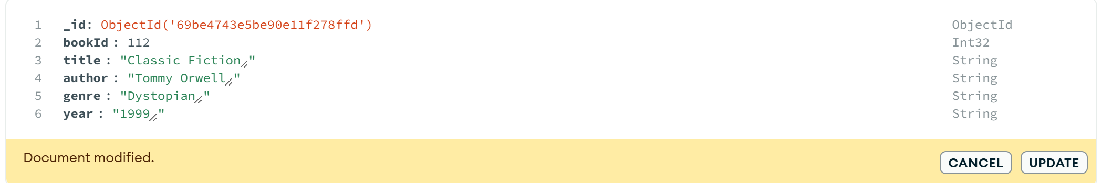
3b)
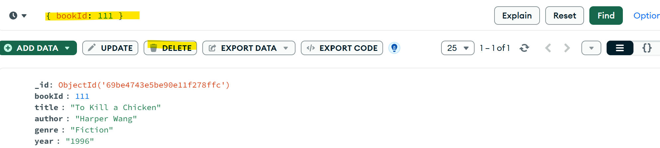
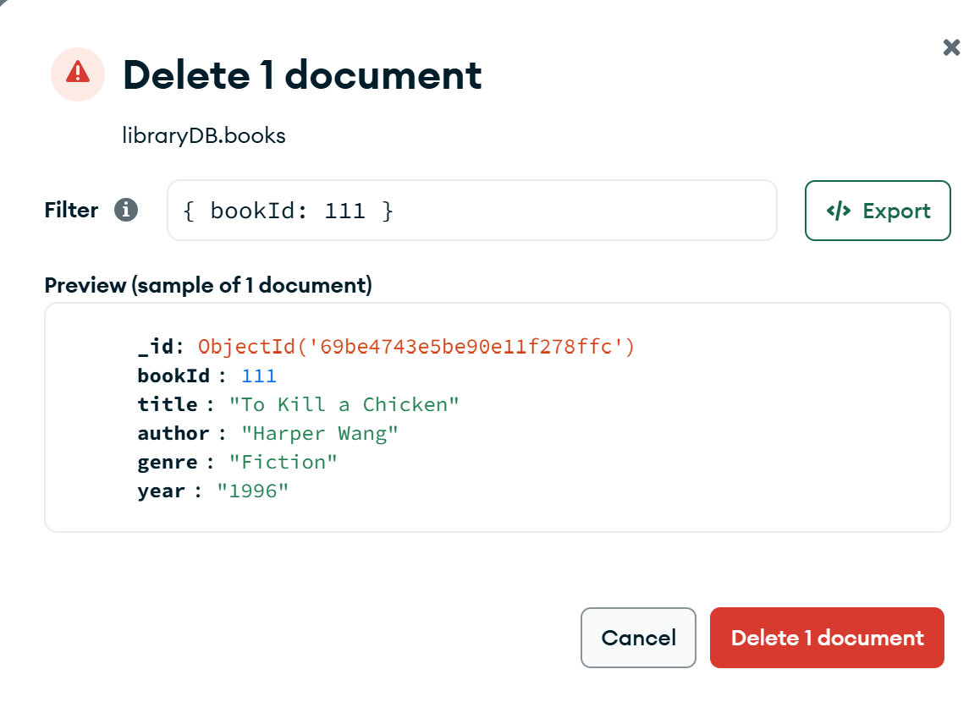
3c)
